Resident News
July –August 2017 Edition
Winter continues to hinder our programs as with the cold and wet we have not been able to have our Wheel Chair Walks, tend the garden or sit in the sun and soak up the warmth!
This winter has also seen a few “bugs” that have limited our activities as we have not been able to hold many of our group programs. Earlier last month we managed to get out to the Morning Melodies in Shepparton, those who attend report this to be a very enjoyable event with sing-along music and a very nice meal for a reasonable fee.
A recent program added to calendar is our post card exchange – this is a program that involves residents receiving and sending postcards to other facilities like ourselves worldwide. To date we have sent out approx 12 cards mostly to the United States and received 4. This program has predominately sent postcards via snail mail however we are becoming a bit hi tech and have recently replied via email with the use facility tablets.
Lifestyle Horticulture Guru Roger assisted residents in the creation of mini terrariums this program would not have been as successful as it proved without the helpful hand of Eddy Stevens wife Noreen who rallied up beautiful jars for us to use, much thanks to Noreen and others who provide us with bits and pieces that assist in our programs. I recently found a surprise on my desk and upon investigation I discovered tins of homemade biscuit’s from Eila Garrard for our Knit Chat and Chew program another much appreciated gift … all we can say is thank you! And yum….
Volunteers are one of the most important resources we have, each brings something special whether they are part of our wheel chair walkers, music masters or part of our reading group. Unfortunately our puzzle master of a Tuesday Gillian has recently had surgery and is away for 6 weeks so are sending out a SOS for assistance. The word game Competition from the last newsletter was mastered with a tally of 25words by June Belcher. Congratulations June the Freddo is yours!
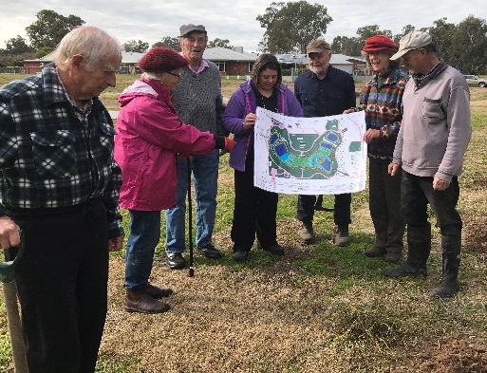
Planting has been underway in the Wet land area, large deciduous trees have been strategically placed to accompany seating that will be installed when weather permits concrete to set. Residents observe with interest and when weather permits enjoy walking the tracks- at last count the pondage housed 18 ducks and a few dab-chicks.
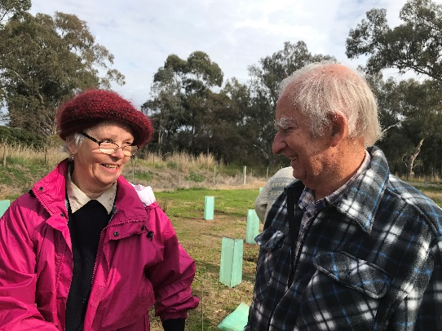

Dates to Remember…
- The next Residents Meeting will be held in the main Lounge on august 7th at 10am followed by morning tea.
- Monthly Lifestyle Activity Calendars are on display on the notice boards in each area.
- Kinda Kids visit and play time will be held in the Main Lounge on August 11th and 25th all welcome. This month’s theme is Bubbles!
- Tuesday Wheel Chair Walkers Volunteer Group meet weekly at 9.30am to enable residents to “get out and see the neighbourhood”
Always recruiting – contact Madonna 57366324
- Laurie the Music Man will visit and play Musical Memories on the August 9th at 1.30pm.
- Early July the Muso Magic Kids from the Evolve Youth Café are dropping in for a Sunday sing along Saturday Aug 12th at 1.30pm
Family welcome to come and enjoy!
- Fish and Chip Friday – 18th August. Please have money and orders ready for Lifestyle on the Wednesday.
- On 31st at 10am Armchair travel this month will take you to Townsville and then on to Mt Isa all without leaving your chair! A Miners “crib” will be provided as refreshments.
- Word game winner for last month was June Belcher with 25words. Congratulations June!

Should you wish to include something of interest to the newsletter please submit to Madonna. Always looking to share news and events of interest.
Word Wizz….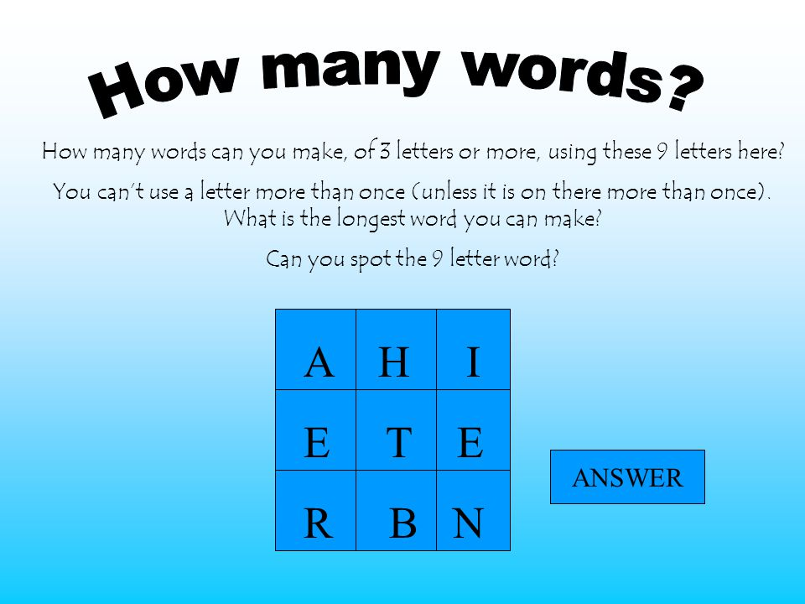
Have a go … see how many you make ,let the Lifestyle staff can know so they can tally the total- there’s a freddo for the winner!

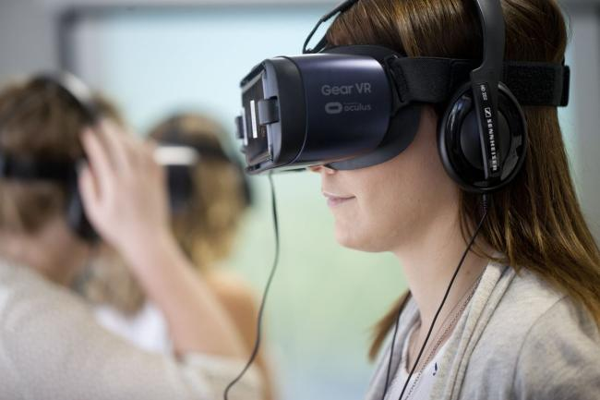
With the support of Alzheimer’s Australia we have a wonderful educational resource that staff will experience to assist in gaining a better understanding of Dementia and how it effects residents. With the use of an App called EDIE and a virtual reality tool staff will see what residents see and experience how it feels. This understanding will assist in our care and strive for best industry practise.

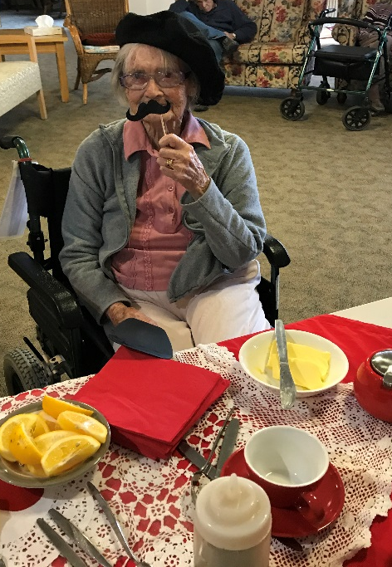
Photo Gallery ….

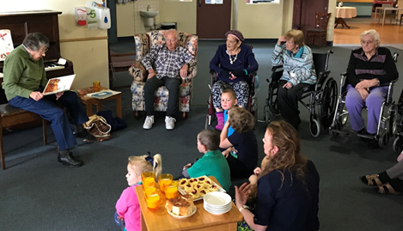
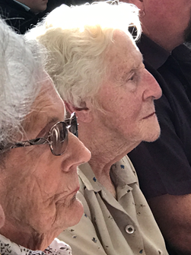
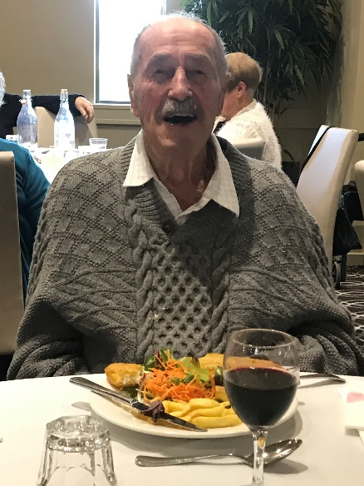
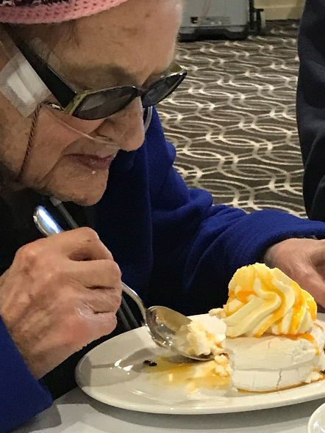
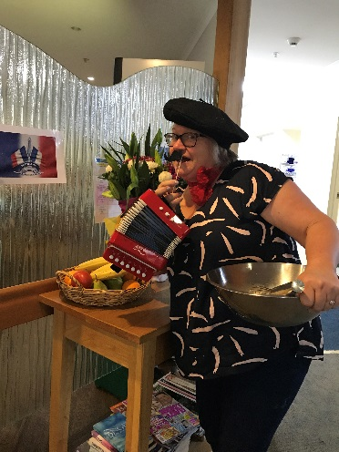
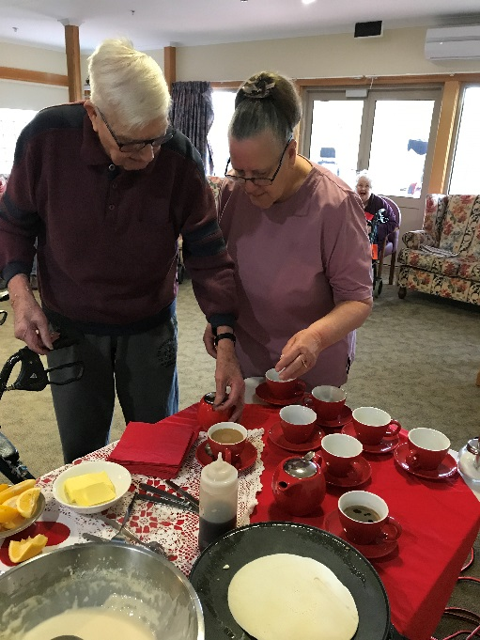
High School Concert and Kinda Kids MUSIC …. A way of life

RSL- Morning Melodies

BASTILLE DAY
CELEBRATIONS

