[](https://www.google.com.au/imgres?imgurl=http://cdn1.bigcommerce.com/server5200/oc3nt/products/367/images/1504/honeysuckle__54594.1398685475.500.500.jpg?c%3D2&imgrefurl=http://www.juicefactory.com.au/tpa-tfa-honeysuckle-concentrate/&docid=2olaW57fscSuyM&tbnid=rl4FwO5EDolKUM:&vet=10ahUKEwiam5TZ25DZAhXHiLwKHXajBFU4ZBAzCEUoQzBD..i&w=500&h=500&bih=588&biw=1186&q=honeysuckle%20flower&ved=0ahUKEwiam5TZ25DZAhXHiLwKHXajBFU4ZBAzCEUoQzBD&iact=mrc&uact=8)

Honeysuckle Herald

**Resident Edition**

January – February 2018

First for the Year ...and a month gone already!

‘The beginning of a new year is like a blank book, it’s your…chance to fill the pages with your story…’

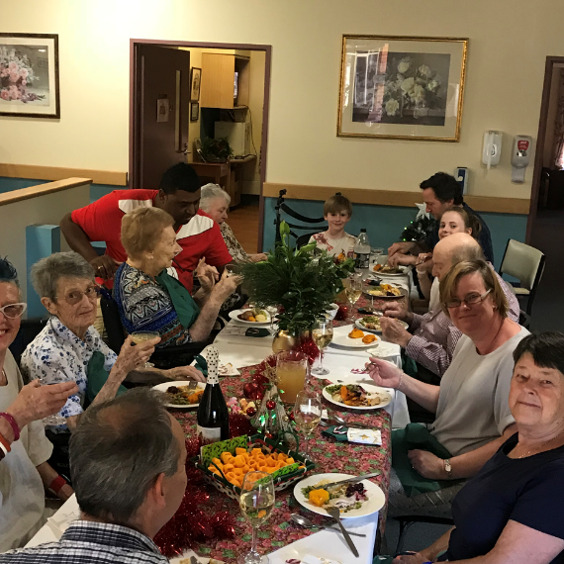Christmas was one of festivities and celebration with a full calendar of events that eclipsed any other year. It was with great pleasure that families felt welcome and joined the celebrations. Each resident received a gift of a Journal from Santa that we hope they will fill with hopes and memories and invite friends and family to add to the story.

If you received a gift of clothing please don’t forget to have the laundry put your name on it with our labelling machine, writing names with pen works for the first wash but then it comes off.

Resident Lifestyle Surveys where sent out early in January, the feedback from the surveys enabled us to plan a calendar of activities with preferences and choice- Bowls being one of the most favoured Activities and it just so happened that The Euroa Third Age Club where looking for a home for a Bowls Mat and Bowls. Another request was for the “takeaway” meals to be more frequent so the Thai Food Truck will visit on the 21st of February.

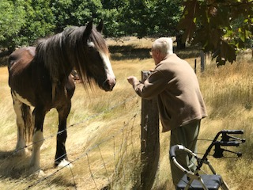The waves of summer heat are expected to continue well into March so we ask you to be mindful- keep hydrated, wear appropriate clothing, stay indoors during the mid -part of the day and if you notice changes to your health let the Registered Nurse on Duty know. One of the other nasties of summer is the snake- to date not one sighting. The Lifestyle Programs will be printed on A3 which means they are larger and will be easier to read. The Lifestyle staff will distribute these on the first day of the Month for your reference. Should you have any suggestions or requests for activity let Lifestyle staff know before the end of the month as they may be able to fit it in as we did with the “Blokes Bus Drive Time” - a recent trip to Strathbogie to check out Madonna’s new horse and have a cupper was a great success.

Newly installed hand washing dispensers have been installed throughout the facility to ensure we follow best practice and health standards. Hand washing has been proven to be one the most effective methods of reducing the spread of germs, bugs and ills!

The Uke Group will visit on the third Thursday of each month and have asked for requests so they can add to their playlist.

Lifestyle have purchased an IPOD and ear phones, this is the beginning of our music therapy program the next step is creating individual playlists, it is proven that Music can reduce stress, engage and provide joy. If you wish to be part of this exciting venture talk to the lifestyle staff they are wanting to hear from you.

““Music reaches the depth of our emotional being and, in particular with people with people with Memory Loss you find memories of years ago are going to be the most vivid,” Dr Cohan

“ Music keeps your ears young. Older musicians don’t experience typical aging in the part of the brain (the auditory cortex) that often leads to hearing troubles. It’s never too late to start taking piano lessons and prevent these age-related changes (The Record.com – Michael Roizen, MD and Mehmet Oz, MD).

The Main Dining Room Experience trial was initiated late in 2017 and has proven to be a success, stage 2 will commence shortly with the evening meal being served in the Main Dining as well as the midday meal. This initiative is to work towards the refurbishment of the Kitchenette and the installation of a Bain Marie as is in the Special Care Unit which enables residents to make meal choices and does away with the Menu system.

You may have noticed how busy our maintenance man Dave is so if you have asked for a job to be done and he’s not been back to for-fill your request it probably slipped his mind. To assist Dave and ensure your requests are for filled please tell care staff and they will log an entry into our maintenance request system.

Roger sends his regards, he is currently not well and is unable to return to work for some time- A Get Well Card is currently doing the rounds so you can add your well wishes.

We want your email address….

Residents, Family and Friends we are updating our communications and request your email addresses.

Please forward to [lifestyle@hsrh.com.au](mailto:lifestyle@hsrh.com.au)

Get Tech Savy @ Violet Town Library

Learn how to use an IPAD or device

The Third Monday of the Month

10am -11.30 am

**Dates to Remember…**

* Resident Hearing and Dental visits can be booked at the Main Nurses Station with the registered Nurse.
* Resident Podiatry visits can be booked with Madonna
* Tuesday Wheel Chair Walkers Volunteer Group meet weekly at 9.30am to enable residents to “get out and see the neighbourhood”
* Always recruiting Volunteers – contact Madonna 57366324
* Residents Meeting Dates .

|  |  |  |  |
| --- | --- | --- | --- |
| February | 9th | 10.30 | M-lounge |
| March | 13th | 10am | M-Lounge |
| April | 10th | 10am | M-Lounge |

***CHURCH SERVICES*** CHAPEL @2.30pm

1st Thursday of each month: Anglican

2nd Thursday of each month: Baptist

4th Thursday of each month: Uniting Church

Catholic Communion - Sunday Only by appointment

Contact Madonna

Morning Meditation 9.30am Wednesday in the Chapel





